# Development and Validation of the HOPE (Helping Online Parents with Engagement)

Qi Guoa

Richard E. Westa

Jered Borupb

aBrigham Young University

bGeorge Mason university

**Abstract**

The purpose of this study was to develop and collect initial evidence of the validity of scores from an instrument intended to identify parents who need help supporting their students’ engagement in online learning. The instrument was also designed to diagnose what level and type of help they need. This study randomly split the 660 participating parents from seven K–12 Indiana online schools into two subgroups. We conducted an exploratory factor analysis (EFA) for one group to form constructs regarding the number of factors represented by the items. We then conducted a confirmatory factor analysis (CFA) for the second group data to assess the factors generated from the EFA results. The results indicated good fit for a three-factor model representing three constructs: (a) parent perceptions of their learner’s independent engagement, (b) parent-offered support to students, (c) parental needs from online schools. Items demonstrated strong reliability within each factor.

*Keywords:* Instrument Development, Validation, Reliability, Online Engagement, Parental Support, School Support

# Introduction

Post-COVID, most public schools in the U.S. have returned to in-person classroom instruction. However, according to the National School Choice Awareness Foundation (NSCAF, 2025), 10% of parents have chosen to transfer their K–12 students to fully online schools. This decision may have been driven by various factors including safety and bullying concerns, health and student well-being, and the flexibility of online learning (Jacobson, 2024; Kokoç, 2019; Repo et al., 2023; Sandberg et al., 2023). Hence, online learning continues to play an important role in meeting the diverse needs of students and families, even as in-person education resumes.

Online students’ academic performance, satisfaction, and overall success can be critically assessed through their engagement in online learning (Borup et al., 2020; Halverson & Graham, 2019). However, online learners, especially young students, are often limited in their ability to engage independently and require a strong level of support to achieve high levels of engagement. Low student engagement is a prevalent issue, and it is strongly influenced by environmental factors, such as the level of support provided by others in their home or class communities (Christenson et al., 2022).

Since parents are often physically present while their children study online, their support often becomes particularly helpful (Hasler-Waters & Leong, 2014; Johnson et al., 2023). As students’ caregivers and first teachers, parents critically influence students’ emotions, behavior, and cognitive development (Shaffer & Kipp, 2013; Tus, 2021). Understanding parental support could help educators and practitioners better support online students. However, in previous research, we identified that parents face a variety of challenges when supporting their students, such as parents in need for additional skills in teaching, parenting, and technology skills (Borup, 2016; Curtis & Werth, 2015; Grobler, 2022; Guo & West, 2025; Holzer et al., 2023), the lack of school support (Garbe et al., 2020; Guo & West, 2025; Kong, 2018), and students’ distraction (Gonzalez-DeHass et al., 2022; Maxwell et al., 2021; Novianti & Garzia, 2020).

To further support parents in addressing their challenges, it is necessary to identify not only which parents need help but also which aspects of support they need help with. To locate our target learners and parents, we need a validated instrument. However, we could not find an instrument specific to online parental support. The instruments we found are either designed for in-person settings or for specific content areas. Therefore, this study aimed to develop and validate an instrument to assess the level and types of support parents need to help their students engage in online learning.

# Literature Review

Our literature review began with a description of the theoretical framework, followed by an exploration of prior research on developing instruments to assess parental support. Lastly, we examined studies on parental support for K–12 online engagement to inform the development of survey items.

## Theoretical Framework

The theoretical framework for this study was the Academic Communities of Engagement (ACE) framework developed by Borup et al. (2020). The ACE framework explores students’ online engagement in affective, behavioral, and cognitive (ABC) engagement dimensions. Student independent engagement is the learning outcome we need to focus on, and it can be promoted through different levels of support: students’ personal community, including support from parents, other family members, and friends, and course community, including support from teachers, peers, and schools. In designing the instrument, we focused on parental and school support to promote students’ independent engagement.

Figure 1  
*ACE Framework*

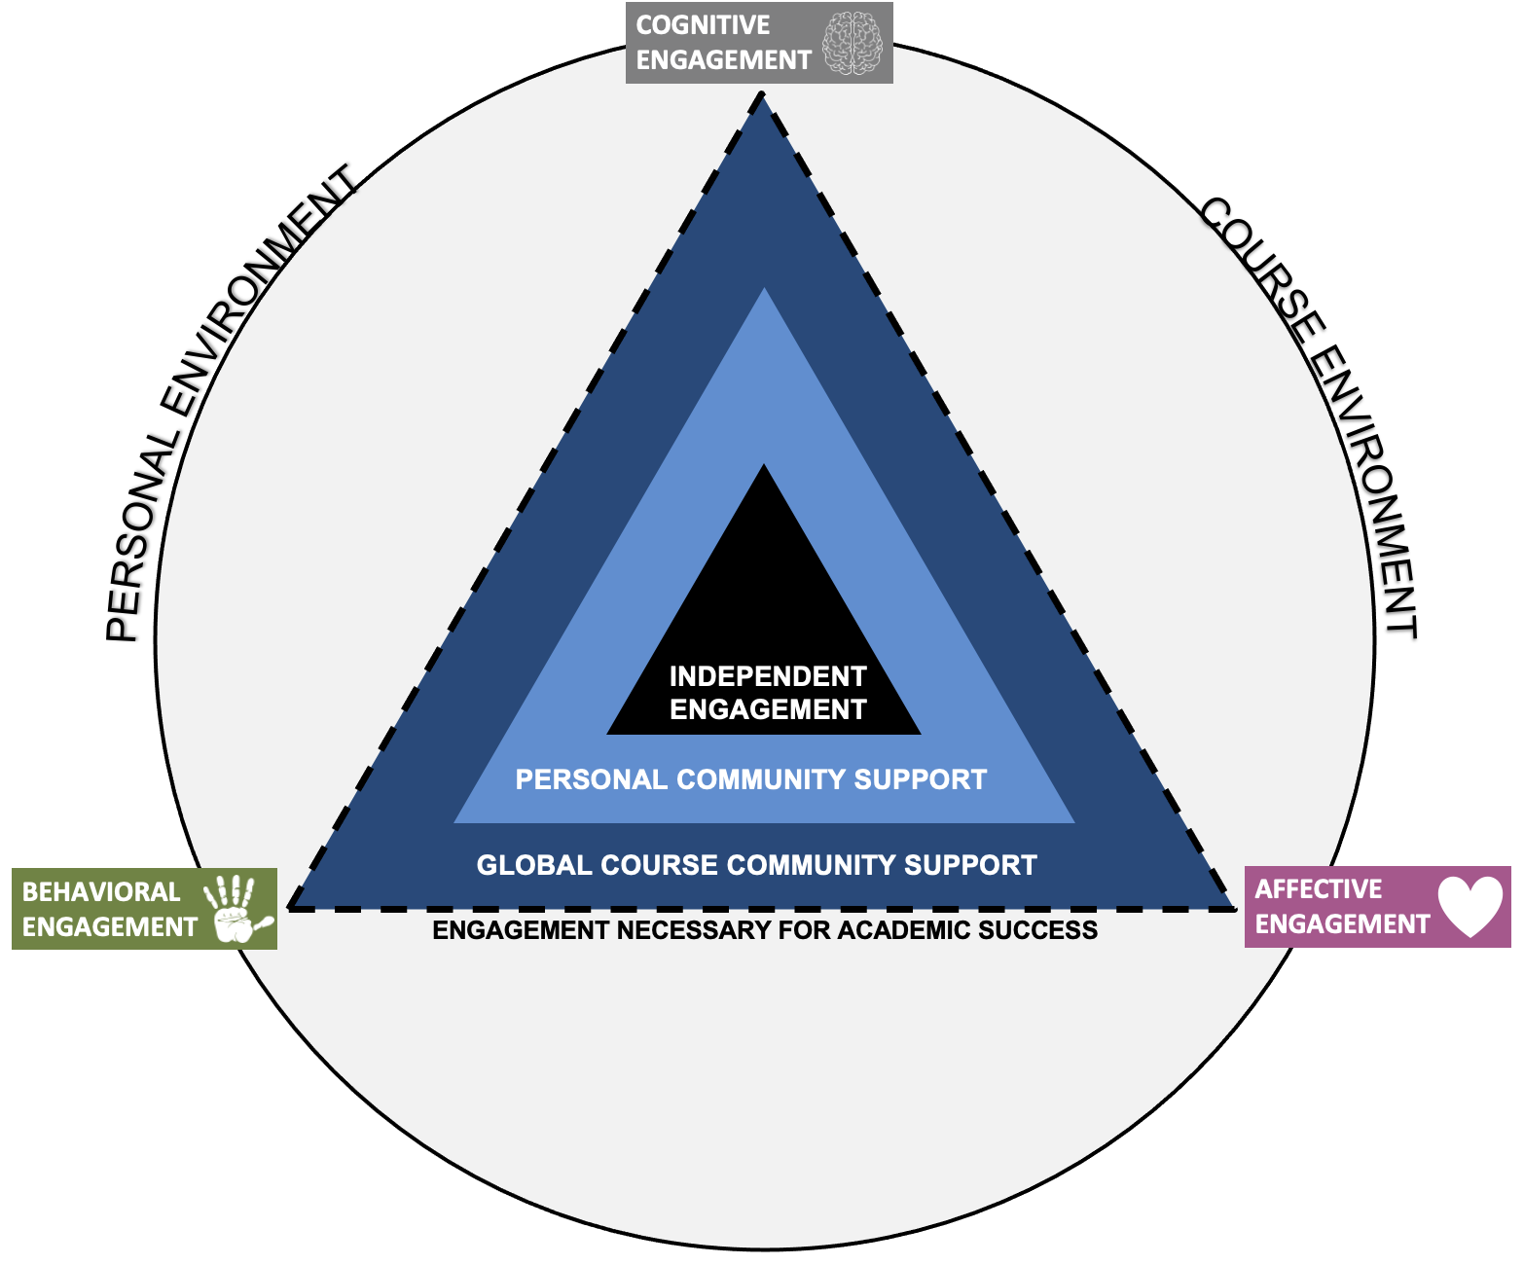

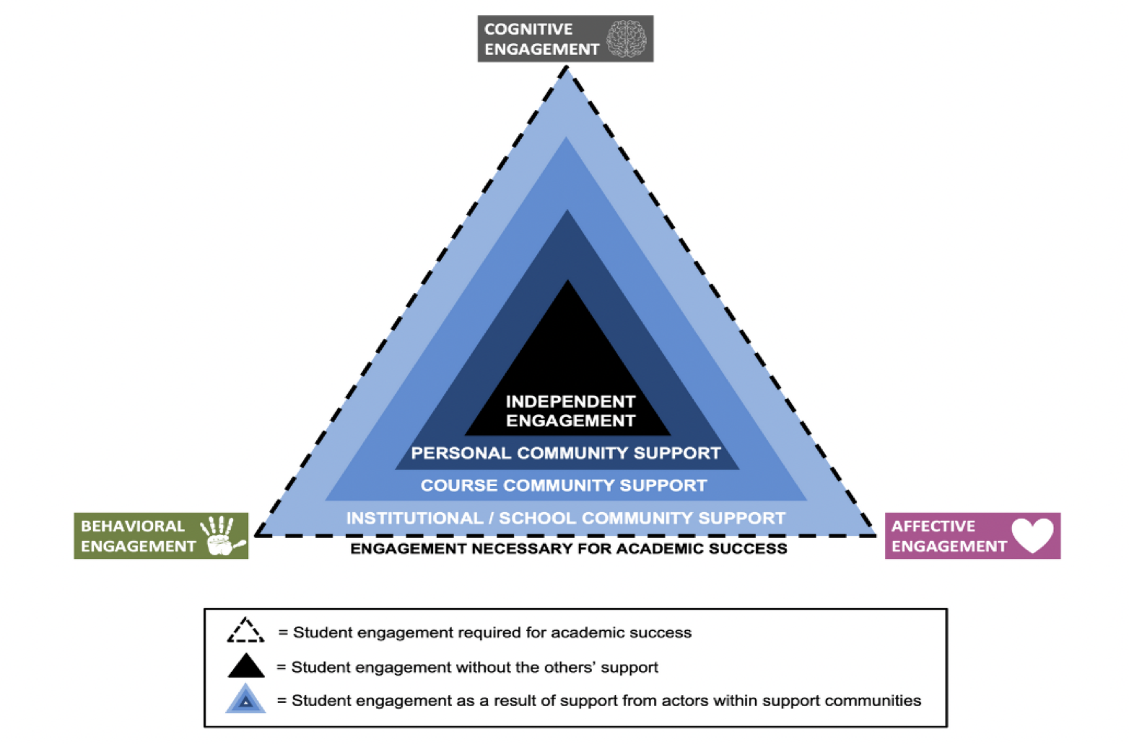

*Note*. This figure was created by Jered Borup and Charles R. Graham, CC BY 2.0.

The ACE framework outlines how communities of support influence students’ engagement across the ABC engagement dimensions. According to Borup et al. (2020), affective engagement refers to the emotional investment in activities, including feelings of enjoyment versus boredom, confidence versus anxiety/frustration, happiness versus sadness, and also personal and situational interest. Behavioral engagement involves the physical action and effort needed to complete learning tasks, such as participating in class activities, submitting assignments, following course instructions on time, and staying on task. Cognitive engagement refers to the mental effort directed towards productive participation, including aspects like attention, concentration, persistence in learning, and the use of cognitive and metacognitive strategies like questioning, exploration, note-taking, and self-assessment for understanding.

However, engagement research has faced persistent challenges in clearly distinguishing among the proposed ABC indicators–particularly between behavioral and cognitive engagement–as cognitive processes are often inferred through observable behaviors, resulting in frequent overlap between the two (Halverson & Graham, 2019; Henrie et al., 2015). Similarly, Rosenberg et al.’s (1960) ABC Model of Attitudes, which conceptualizes attitudes as incorporating affective, behavioral, and cognitive components, has been the subject of ongoing debate regarding whether these components function as one, two, or three distinct factors. While some studies using multimodal measures have identified distinct components (e.g., Garcia-Santillan et al., 2012), many have reported high intercorrelations (Breckler, 1984; Fishbein & Raven, 1962). Overall, the literature suggests that the ABC components often blend together (Bagozzi & Burnkrant, 1979; Breckler, 1984; Fishbein & Raven, 1962; Hussain, 2024).

## Research on the Development of Parental Support Instruments

Previous researchers have developed instruments to assess parental support. For example, Lam et al. (2020) developed a survey assessing the relationship between parental beliefs regarding their roles and responsibilities and their actual practices. The survey has 33 items under five sections: (a) “parental love & nurturing,” (b) “parenthood as a normative life stage,” (c) “readiness to relax and restrict parental control,” (d) “parental guidance of the young,” and (e) “fulfillment of children’s needs.” The participants of this study included 5,521 Chinese parents from five generational cohorts. Both Exploratory Factor Analysis (EFA) and Confirmatory Factor Analysis (CFA) identified five stable components intrinsic to the 33 parental belief statements. The survey demonstrated good internal consistency, significant correlations between the scale and its sub-scales, and revealed notable differences among the five generational cohorts. Compared to existing tools focusing mainly on children’s emotions or anxiety, this survey took a multidimensional approach and focused on parents. It addressed both parental beliefs related to child-rearing and parents’ own experiences, as well as development in parenthood.

Some studies focused on parental support for students’ emotions, such as Elfström and Ahlen’s (2022) study, which developed a questionnaire to measure parental modeling of anxiety. This questionnaire included 51 items covering aspects of parental modeling of both anxious and non-anxious behaviors. Participants were 1,092 Swedish parents with children aged 4–12. Factor analysis of the parental modeling items revealed a structure with four distinct factors, representing four subscales: “(a) being curious and content, (b) being vigilant, (c) displaying anxiety and avoidance, and (d) displaying stress” (p.1). The Cronbach alpha coefficients for the subscale scores indicated moderate to good reliability. Linear regression analysis demonstrated that the subscale measuring displaying anxiety and avoidance had the strongest association with child anxiety symptoms. According to the results of the study, the questionnaire indicated satisfactory psychometric properties and showed potential for application in both research and clinical settings, and it could help identify targets for parenting interventions and measure mediation effects.

Other studies developed instruments intended to assess parenting style. Different parenting styles have been tested to influence students’ growth in different ways (Baumrind, 1978). Reitman et al. (2002) revised an existing Parental Authority Questionnaire and assessed the reliability and validity of the questionnaire on the authoritarian, authoritative, and permissive parenting styles with a large and diverse sample of parents and students. Results suggested that the factor structure of the revised questionnaire was notably affected by sample attributes such as the socioeconomic status and ethnicity of participants. The authoritarian and permissive scales exhibited moderate reliability, while authoritativeness exhibited low reliability among individuals from lower socioeconomic backgrounds.

While a range of instruments has been employed in parental research, current instruments often exhibit developmental limitations in one of three ways. First, instruments may focus on specific aspects or content areas, such as (a) students’ self-regulation (Moilanen, 2007), (b) parenting (Reitman et al., 2002), (c) sports, or (d) drawing (de Groot et al., 2023; Zheng & Yang, 2022), or students’ or parents’ emotion (Cohodes et al., 2022; Elfström & Ahlen, 2022). Moreover, although the instruments focus on parental involvement, the respondents may be children, rather than parents (Moilanen, 2007). Also, these instruments might not specifically focus on online learning settings (Lam et al., 2020). Therefore, there is a need to develop an instrument that assesses parental support in online settings.

## Research on Parental Support of K–12 Online Engagement

We previously conducted two studies with eight Indiana online schools regarding their parental and school support. Both studies were based on the ACE Framework. When formulating the current instrument items, we referred to the results from both studies.

Sandberg et al. (2023) conducted a qualitative study by interviewing 21 parents selected from the eight online schools in Indiana. Parents’ interviews concluded that parents believed that they should take primary responsibility for students’ behavioral engagement, while teachers should focus more on students’ cognitive engagement. Both teachers and parents should be responsible for supporting students’ affective engagement with different tasks; teachers need to make the content more fun and engaging, while parents should provide emotional support for their students. This paper also identified additional parental support that could be added to the ACE framework, including “helping students move to an online school, increasing personal availability, leveraging resources, teaching themselves, and encouraging students to develop independent engagement skills” (p. 2).

In the study by Guo et al. (2024), the authors used the Survey of Online Academic Parental Support to measure parental online engagement from 568 parents of eight Indiana online schools. This study indicated that parents generally believed they successfully supported their students’ online engagement, but their students’ needs were not fully met. Parents perceived that they faced affective, behavioral, and cognitive challenges when supporting their online students: “students’ lack of motivation; challenges in keeping on pace; lack of organization, learning materials, live sessions, and support from online schools; lack of feedback, support, and communication from teachers; parents’ lack of competencies in supporting students’ online engagement; and parents’ unawareness of students online learning” (p.1).

We learned from the previous studies that specific gaps needed further investigation. Thus, we need to delve deeper into the following areas to expand our understanding of online parental support: the ABC support parents offered to students, support parents offered to increase students’ independent engagement, and parents’ expectations of support needs from schools. To fill this gap, the purpose of this study was to develop and validate a survey that help identify target parents who need help to support their students’ online engagement.

# Method

Through the lens of the Academic Communities of Engagement (ACE) framework and the dimensions of affective, behavioral, and cognitive (ABC) engagement, this study aimed to develop an instrument to assess the various dimensions of parental support for K–12 students and their impact on students’ engagement in online learning. The study focused on two research questions.

1. Which measurement model best fits the data?

2. What is the estimated reliability of the items measuring each factor?

## Instrument Development

The ACE framework examines parents’ efforts to support students’ independent engagement through affective, behavioral, and cognitive (ABC) roles. Accordingly, it is important to include items that measure students’ independent engagement across these three dimensions. Previous research has shown that parents often encounter challenges corresponding to these ABC support roles, as well as a lack of support from online schools and teachers. Therefore, items should also capture parents’ perceptions of their needs for school-based support. Since these challenges are closely linked to students’ engagement in the ABC domains, it is essential to include items assessing the specific ABC support parents provide to their children.

Drawing on these findings, the research team proposed five latent constructs: (a) parent perceptions of their learner’s independent engagement; (b) parent-offered affective support; (c) parent-offered behavioral support; (d) parent-offered cognitive support; (e) parental needs from online schools. Then, they drafted items under the five latent constructs, as shown in Figure 2.

Figure 2

*HOPE Items Classified by Five Proposed Constructs*

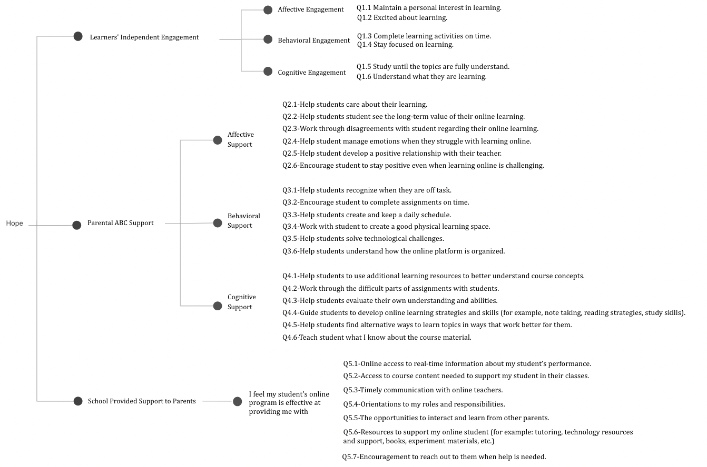

Because the researchers also aimed to collect student demographic information, they developed four categories of survey items: (a) parent perceptions of their learner’s independent engagement; (b) parent-offered ABC support; (c) parental needs from online schools; and (d) demographics.

According to DeVellis (2017) and Worthington and Whittaker (2006), it is recommended 4–6 items per construct being ideal for internal consistency and interpretability. To prevent underestimation due to too few items per construct while avoiding participant fatigue, the research team carefully determined the number of items in each section.

The drafted items were then reviewed by four experts in the instructional technology field to identify any unnecessary or unclear items or any statements that failed to comply with accepted guidelines. Next, we invited administrators from four online schools and program in a Midwestern state to review the instrument as practitioner reviewers. We revised the instrument items based on the suggestions provided by the experts and practitioner reviewers. See Appendix 1 for a full list of items.

## Data Collection

IRB approved this study in May 2024. We administered the instrument to eight K–12 Indiana online programs and collected data over a 10 month period from May 2024 to March 2025.

### Participants

We employed purposive sampling to recruit parents from eight online schools or programs located across a Midwestern state, representing a variety of educational settings—including full-time online schools, supplemental programs, and charter schools in rural, urban, and suburban areas. In selecting sites, we intentionally included both programs that primarily offered synchronous instruction and those that primarily delivered courses asynchronously.

Seven out of eight online schools and programs participated in the study, resulting in 838 parents responses. After excluding incomplete responses, 660 were retained for analysis. Among the respondents, 83% were mothers, with 26% of parents supporting their elementary students, and 74% of parents supporting their secondary students. The demographic breakdown showed that 78% of the students were White, 11% were Black, and 53% were female. Regarding special education plans, 28% of the students were on an IEP, 11% were on a 504 plan, and 8% were identified as having high ability. Additionally, 75% of the students were enrolled in full-time online programs, with 43% in their first or second year of online learning. See Figure 3 for a year’s breakdown of students’ online learning experiences.

Figure 3  
*Students’ Online Learning Experiences*

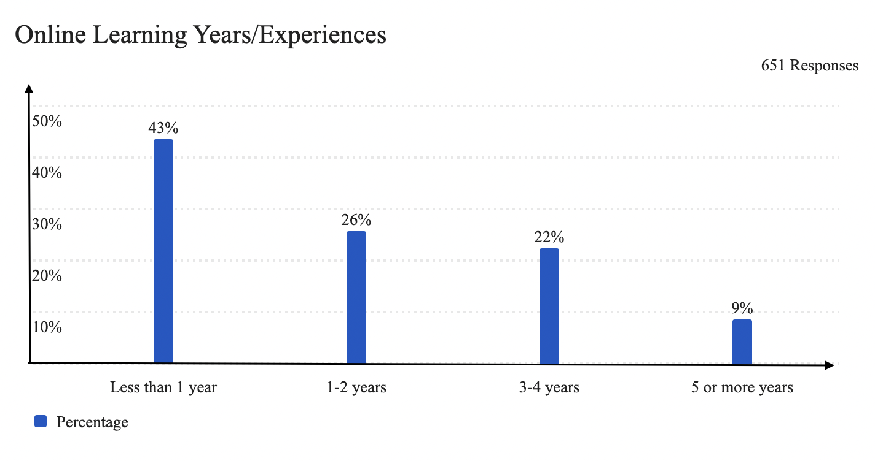

Figure 4 indicates that 72% of students participate in synchronous sessions daily or multiple times a week, while 38% primarily engage in asynchronous learning.

Figure 4  
*Synchronous vs. Asynchronous*

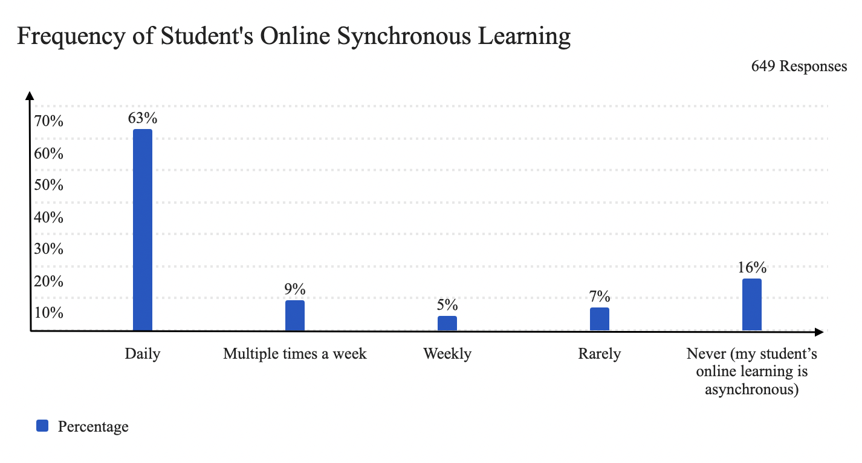

## Data Analysis

In data analysis, EFA was used initially to explore how the observed variables group together and to identify the underlying latent factors. CFA was then used to test how well the observed data fit this theoretical structure.

We first used SPSS to code missing data as -99, then divided the responses into two random subsamples based on case order: the odd-numbered and even-numbered halves. This approach was used to stratify the responses so that participants from the same school were distributed as evenly as possible across both groups. Next, we used Mplus to conduct an EFA on the odd numbered half to identify the number of factors, which items loaded on which factors, which items had high cross loadings, and which items did not load on any single factor. When conducting EFA in Mplus, the default oblique rotations were used to allow factors to correlate. Based on the results of the EFA, we conducted a CFA on the even numbered half, to assess the factors generated from the EFA results. The goal of CFA was to cross-validate the findings of the EFA.

# Results

In this section, we begin by presenting the results of the EFA and CFA analyses. Following, we report the evidence of reliability and validity.

## EFA Results

We first determined the number of factors to retain in the model based on the EFA results. Reviewing the output from various EFA models, we observed the eigenvalues and percent of variance explained as shown in Table 1. According to Kaiser (1960), any factor with a eigenvalue less than one means the factor explains less variance than a single item, so it’s unlikely to represent a stable construct. Since the eigenvalue for the fourth factor is 0.991, we preliminarily decided to exclude models with four or more factors.

###### Table 1 *Eigenvalues and Percent of Explained Variance*

|  |  |  |  |  |
| --- | --- | --- | --- | --- |
| Factor | Factor Name | No. of Items | Eigenvalue | Percent of Variance Explained (%) |
| 1 | Students’ Independent Engagement | 6 | 7.015 | 54.89 |
| 2 | Parental Support to Students | 18 | 2.669 | 63.50 |
| 3 | School-Provided Support to Parents | 7 | 2.048 | 70.11 |

Next, we examined the factor loadings for the two-factor, three-factor, and four-factor models. Cross-loadings of items Q 2.1, 2.3, and 2.4 (affective support items) were observed in the two-factor model, leading us to continue with the three-factor and four-factor models for further evaluation. For the four-factor model, no item was loaded onto the fourth factor, except for some close loadings of Items Q 2.1-6 (affective support items). Combined with the eigenvalue being less than one, led to the rejection of the four-factor model.

All items are loaded on three factors separately without cross-loadings for the three-factor model, as shown in Table 2. Therefore, we retained the 3-factor model.

###### Table 2 *Factor Loadings for the Three-Factor EFA Model*

|  |  |  |  |
| --- | --- | --- | --- |
|  |  | Factor |  |
| Item | 1 | 2 | 3 |
| Q1.1 | 0.776* | 0.006 | 0.212 |
| Q1.2 | 0.703* | 0.038 | 0.177 |
| Q1.3 | 0.645* | -0.054 | 0.211 |
| Q1.4 | 0.839* | -0.024 | 0.157 |
| Q1.5 | 0.776* | 0.097 | 0.115 |
| Q1.6 | 0.594* | 0.100 | 0.138 |
| Q2.1 | 0.350* | 0.624* | -0.009 |
| Q2.2 | 0.375* | 0.701* | -0.158* |
| Q2.3 | 0.283* | 0.844* | -0.256* |
| Q2.4 | 0.271* | 0.862* | -0.200* |
| Q2.5 | 0.175* | 0.534* | 0.207* |
| Q2.6 | 0.207* | 0.739* | 0.032 |
| Q3.1 | -0.021 | 0.676* | 0.182* |
| Q3.2 | 0.189* | 0.639* | 0.132* |
| Q3.3 | 0.160* | 0.589* | 0.228* |
| Q3.4 | 0.029 | 0.545* | 0.310* |
| Q3.5 | -0.031 | 0.597* | 0.239* |
| Q3.6 | -0.095* | 0.646* | 0.304* |
| Q4.1 | -0.105* | 0.765* | 0.167* |
| Q4.2 | -0.130* | 0.792* | 0.124* |
| Q4.3 | 0.018 | 0.879* | -0.005 |
| Q4.4 | 0.004 | 0.782* | 0.134* |
| Q4.5 | -0.048 | 0.824* | 0.061 |
| Q4.6 | -0.194* | 0.851* | 0.003 |
| Q5.1 | 0.034 | 0.201* | 0.710* |
| Q5.2 | -0.023 | 0.145* | 0.762* |
| Q5.3 | 0.116* | -0.008 | 0.777* |
| Q5.4 | -0.004 | 0.188 | 0.734* |
| Q5.5 | -0.007 | 0.125 | 0.710* |
| Q5.6 | 0.039 | 0.195* | 0.749* |
| Q5.7 | 0.080 | 0.150* | 0.728 |

Since the items measuring parental ABC support were originally designed to load onto three distinct factors, it was unexpected that all 18 of the items would clustered on the same factor. To further investigate whether ABC engagement support could be differentiated, we conducted another EFA focused exclusively on the 18 items that loaded on the second factor by temporarily removing items associated with the first and third factors. However, the EFA results showed that all behavioral and cognitive items continued to load onto a single factor. Based on this outcome, we decided to proceed with the original three-factor model.

## CFA Results

We used even-numbered cases from the original data and conducted CFA to further confirm the three-factor model. The resulting factor loadings, standard errors, and inter-factor correlations are displayed graphically in Figure 5. Note that all factor loadings on each of the three factors exceed .70. The fit indices show CFI = .965, TLI = .962, RMSEA = .075, and SRMR = .044. The correlation between factor 1 and 2 is .698, the correlation between factor 1 and 3 is .613, and the correlation between factor 2 and 3 is .770, indicating a moderately strong positive correlation among factors. These values indicate moderately strong and consistent positive relationships among the three factors.

In sum, the responses of HOPE are a good fit for a three-factor model: (a) Students’ Independent Engagement, (b) Parental ABC Support, and (c) School Provided ABC Support to Parents.

Figure 5   
*Path Diagram*

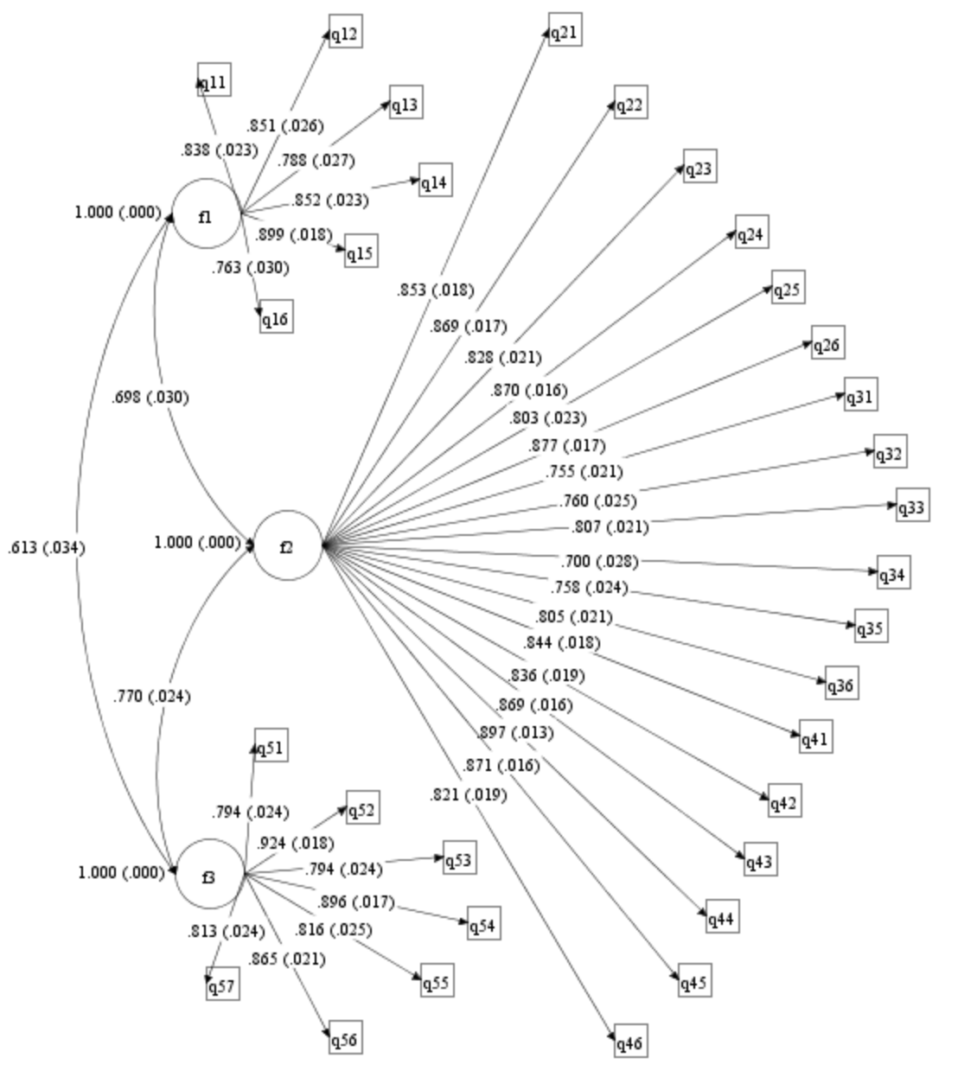

## Reliability

We computed Cronbach’s Alpha for each factor using SPSS, and all of them were above .9, indicating strong reliability. However, given the assumptions associated with Cronbach’s alpha, we further calculated McDonald’s omega coefficient for each factor based on the factor loadings and residuals. Since McDonald’s omega does not assume equal item contributions as Cronbach’s alpha, it adjust for measurement error. It also provides a more realistic reliability estimate, therefore, the values were slightly lower than Cronbach’s alpha but still demonstrated good item reliability for each factor, as shown in Table 3.

###### Table 3 *Reliability*

|  |  |  |  |  |  |
| --- | --- | --- | --- | --- | --- |
|  |  |  |  | Estimated Reliability | |
| Factor Names | Number of Items | Mean | ST. Variance | Cronbach’s Alpha | McDonald’s Omega |
| Students’ Independent Engagement | 6 | 26.05 | 6.66 | 0.909 | 0.857 |
| Parental Support | 18 | 89.78 | 14.41 | 0.962 | 0.947 |
| School-Provided Parental Support | 7 | 33.43 | 7.21 | 0.915 | 0.875 |

## Validity

Our instrument was reviewed by expert and practitioner evaluators and provided evidence of content validity. In the CFA, items loaded exclusively onto their respective constructs without significant cross-loadings, demonstrating evidence of structural validity.

# Discussion

The results demonstrate initial evidence of structural validity for the HOPE instrument. The three factors include: (a) Students’ Independent Engagement, (b) Parental ABC Support, and (c) School-Provided ABC Support to Parents. The first two factors, Students’ Independent Engagement and Parental ABC Support, are directly reflected within the ACE framework. However, the third factor, School-Provided ABC Support to Parents, is not explicitly addressed in the current framework (see Figure 6). Therefore, this study suggests expanding the ACE framework to incorporate interactions between different layers of community support (as shown in Figure 7).

Figure 6   
*Mapping the Three-Factor Model of HOPE Onto the ACE Framework*

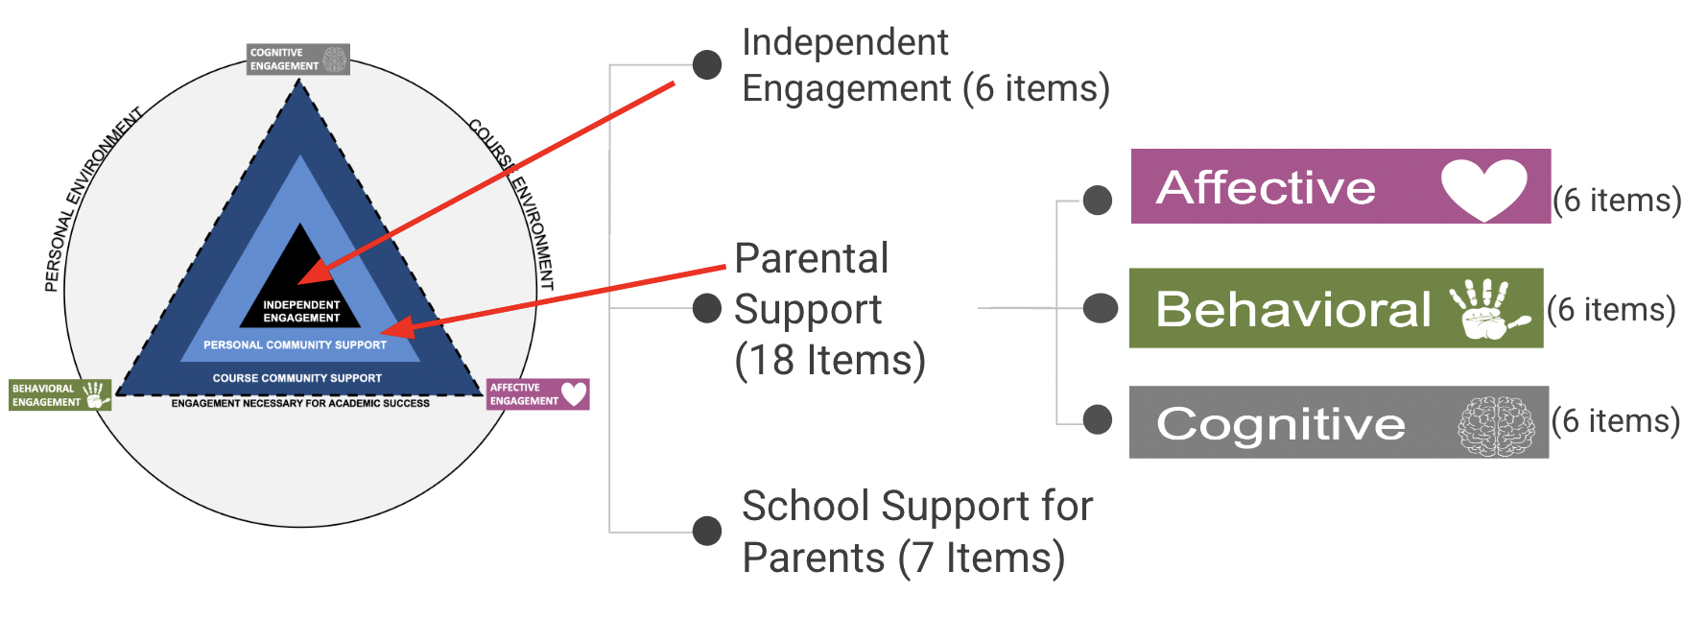

Figure 7  
*Visualizing the Interaction Between Personal and Course Community Layers in the ACE Framework*

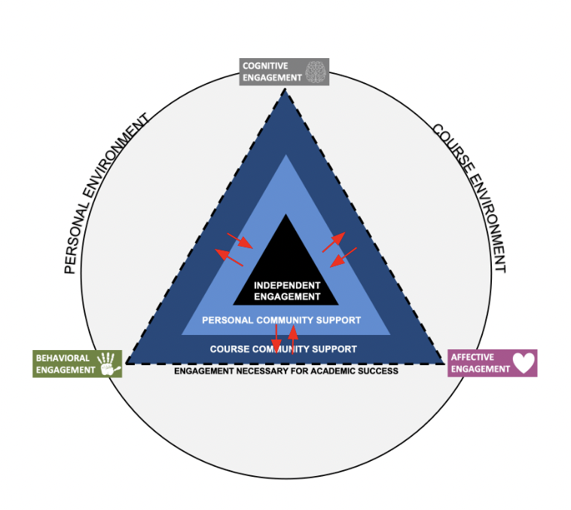

This study is not the first to identify the interactions between different layers of community support. Parents in Hanny’s (2022) research were found to actively seek course community support by intentionally selecting the course community, connecting students to school resources, and advocating for their students’ needs within the school system. Similarly, Guo et al. (2024) suggested that parents enhance the interaction between personal community and course community support by engaging in school communities and initiating conversations with teachers and online schools. The current study further recommended that course community support can influence parental support community. These findings indicate that the interactions between school and parent communities are bidirectional, meaning they can originate from either parents or schools. Based on these insights, this study recommends using the ACE framework to account for the dynamic interplay between multiple layers of community support.

Unfortunately, we were not able to distinguish between parents’ (a) affective, (b) behavioral, and (c) cognitive support based on the parents’ responses. When digging deeper into the reasons, we found three possible answers.

From the schools’ point of view, this is a voluntary survey, and parents who completed this survey maybe the ones who support their students at a higher level. As shown in the results, 83% of the survey takers were mothers. If more fathers or parents who are less involved in their students’ learning are included, the results might present more variations about the ABC types of support. This is reflected by La Greca and Silverman (1993), who discovered that more engaged parents are overrepresented in survey samples, potentially introducing bias in research findings.​

From the parents’ point of view, parents’ difficulty distinguishing among these types of support when answering the instrument questions could be one reason. In their literature review, Colalillo and Johnson (2016) supported this view by describing how parents’ affect, behaviors, and cognition are mutually influential, suggesting that parental support often blends ABC dimensions, making it difficult for parents to clearly differentiate among them. Another possible reason is that parents consistently provide affective support—such as showing love and emotional encouragement—which may ultimately influence their children’s behavioral and cognitive engagement.

The ABC Model of Attitudes derived from social psychology provides explanations from researchers’ point of view. According to Rosenberg et al. (1960), the ABC Model of Attitudes, affective, behavioral, and cognitive components are a part of attitude and are often used to explain how attitudes are structured and function. There is a long history of arguments about whether the ABC Model of Attitudes is a single-factor, two-factor, or three-factor model. Sometimes distinct factor structures emerge, especially with multimodal instruments (Garcia-Santillan et al. 2012). Graham et al. (2023) have differentiated among the ABC dimensions of engagement and the corresponding types of institutional support. Breckler (1984) revealed that when only verbal reports were used and the physical presence of the attitude object was absent, the ABC components exhibited high intercorrelations. Conversely, incorporating nonverbal measures and the actual object led to more distinct components. However, despite the use of various measurement methods, the three components were highly interrelated in Fishbein and Raven’s (1962) study. Most studies proved that the ABC components blend together. For example, affect and cognition were found to be highly intercorrelated (Bagozzi & Burnkrant, 1979; Breckler, 1984; Fishbein & Raven, 1962; Hussain, 2024). Whereas, behavioral and cognitive engagement were intertwined in the study by Halverson and Graham (2019).

In sum, the findings provided evidence of validity for the HOPE as a three-factor model, which aligned with the ACE framework in two areas—Students’ Independent Engagement and Parental ABC Support—while revealing a third factor, School-Provided ABC Support to Parents, is not reflected in the current ACE framework. Thus, this study suggests expanding the framework to include interactions across layers of community support. While parents may not consciously differentiate among affective, behavioral, and cognitive support types, their combined use of ABC support plays a significant role in students’ online engagement.

# Limitations and Implications

One of the limitations of this study is that parents’ affective, behavioral, and cognitive support were unable to be distinguished based on the survey responses. This could be due to parents’ difficulty in distinguishing among these types of support when answering the instrument questions, or it may be that they consistently provided all three types of support to their students. Future research could focus on refining the instrument items to make them more distinct and assess whether parents can effectively differentiate among the three types of ABC engagement support.

As aforementioned, another reason could be that parents who responded to this survey are the main caregivers who provide the most support to their students. These items could be highly correlated because these main caregivers probably provide all three types of supports. Future studies could collaborate with online schools and programs to include more parents who are less involved in their students’ learning in the survey and re-evaluate the results to see whether it is distinguishable among the three types of support.

Another reason for this was the potential length of the survey, which was also a concern for school administrators. To minimize response bias, future research should clearly communicate to parents that the purpose of the survey is not to evaluate their performance. Additionally, researchers might consider changing the question stem from “I can be successful at…” to asking parents what specific actions they are currently taking, rather than focusing solely on what they believe they are doing well.

Although the instrument has its limitations, it remains practical and useful. Online schools can use it to measure parental support across all ABCs, encourage increased support in weaker areas, and identify students and parents needing additional support. Parents can also use this instrument to self-assess their needs and support efforts, and deliver targeted resources immediately after the survey and beyond.

Future research could delve deeper into whether the different dimensions of engagement are truly distinct constructs or if they represent one or two broader, overarching engagement constructs. Further exploration could also focus on refining and validating the specific indicators used to represent each type of engagement, ensuring they accurately capture the nuances of students’ experiences across different contexts. This work would contribute to a more precise and comprehensive understanding of engagement, especially in online learning environments.

One of the key findings of this study is the proposal to use the ACE framework to include the interactions between different layers of community support. While previous studies, such as Hanny (2022), have shown that parents actively seek course community support with schools, relatively rare research has investigated how schools, in turn, provide support to parents. Therefore, future studies could examine the nature and effectiveness of school-provided support for parents, and how such support interacts with parental efforts on students’ learning engagement. Understanding this synergy may inform more holistic support systems that foster stronger partnerships among students, parents, and schools.

Future research could work on generating personalized reports to parents who complete the survey, helping parents diagnose their supporting roles and deliver targeted interventions to those in need. Additionally, a more well-rounded understanding could be achieved if future studies use this instrument to gather students’ perspectives on the support they received from their parents and online schools. This could help identify students who may need additional support. Since some parents require more assistance than others, identifying trends—such as among homeschooling families or other specific profiles—could provide valuable insights for schools in tailoring their support strategies.

# Conclusion

This study developed and collected validity evidence for the HOPE instrument to identify parents who need help with supporting their students’ engagement in online learning, to understand in which aspect in which they need help, and to assess the level of help needed. Guided by the ACE framework, 660 parents’ responses from seven Indiana online programs were analyzed. Through the EFA and CFA, we identified and confirmed that the item measure three positively correlated factors: (a) parent perceptions of their learners’ independent engagement; (b) parent-offered support to students; and (c) parental needs from online schools. Each factor showed strong internal consistency among its items. The study suggests that the HOPE instrument is a practical tool that can help online schools measure parental support across all ABC supports, identify parents and students needing additional support, and encourage increased support in weaker areas. Parents can also use it for self-assessment. The findings also suggest using the ACE framework to include the interaction between different layers of community support, particularly the support online schools provide to parents, as this emerged as a significant third factor in the model that was not explicitly addressed in the original framework.

# References

Bagozzi, R. P., & Burnkrant, R. E. (1979). Attitude organization and the attitude–behavior relationship. *Journal of Personality and Social Psychology, 37*(6), 913–929. [https://doi.org/10.1037/0022-3514.37.6.913](https://psycnet.apa.org/doi/10.1037/0022-3514.37.6.913)

Baumrind, D. (1978). Parental disciplinary patterns and social competence in children. *Youth & Society, 9*(3), 239–267. <https://doi.org/10.1177/0044118X7800900302>

Borup, J. (2016). Teacher perceptions of parent engagement at a cyber high school. *Journal of Research on Technology in Education, 48*(2), 67–83, https://doi.org/10.1080/15391523.2016.1146560

Borup, J., Graham, C. R., West, R. E., Archambault, L., & Spring, K. J. (2020). Academic communities of engagement: An expansive lens for examining support structures in blended and online learning. *Educational Technology Research and Development*, *68*(2), 807–832. <https://link.springer.com/article/10.1007/s11423-020-09744-x>

Breckler, S. J. (1984). Empirical validation of affect, behavior, and cognition as distinct components of attitude. *Journal of personality and social psychology, 47*(6), 1191–1025. [https://doi.org/10.1037/0022-3514.47.6.1191](https://psycnet.apa.org/doi/10.1037/0022-3514.47.6.1191)

Christenson, S., Reschly, A. L., & Wylie, C. (2022). *Handbook of research on student engagement* (Reschly, A. L., & Christenson, S. L. Ed.). Springer.

Cohodes, E. M., Preece, D. A., McCauley, S., Rogers, M. K., Gross, J. J., & Gee, D. G. (2022). Development and validation of the parental assistance with child emotion regulation (PACER) questionnaire. *Research on Child and Adolescent Psychopathology*, *50*(2), 133–148. https://doi.org/10.1007/s10802-020-00759-9

Colalillo, S., & Johnston, C. (2016). Parenting cognition and affective outcomes following parent management training: A systematic review. *Clinical Child and Family Psychology Review, 19*, 216–235. https://doi.org/10.1007/s10567-016-0208-z

Curtis, H., & Werth, L. (2015). Fostering student success and engagement in a K–12 online school. *Journal of Online Learning Research, 1*(2), 163–190. <https://www.learntechlib.org/primary/p/150962/>

De Groot, B., Gorr, N. D., Kret, M. E., Rieffe, C., Tsou, Y. T., & Straffon, L. M. (2023). Development and preliminary validation of a questionnaire to measure parental support for drawing. *Thinking Skills and Creativity*, *47*(101228). <https://doi.org/10.1016/j.tsc.2022.101228>

DeVellis, R. F. (2017). *Scale Development: Theory and Applications* (4th ed.). Sage Publications.

Elfström, S., & Ahlen, J. (2022). Development and validation of the Modeling of Parental Anxiety Questionnaire. *Journal of Anxiety Disorders*, *85*(102515). https://doi.org/10.1016/j.janxdis.2021.102515

Fishbein, M., & Raven, B. H. (1962). The AB scales: An operational definition of belief and attitude. *Human relations, 15*(1), 35–44. <https://doi.org/10.1177/001872676201500104>

Garbe, A., Ogurlu, U., Logan, N., & Cook, P. (2020). COVID-19 and remote learning: Experiences of parents with children during the pandemic. *American Journal of Qualitative Research, 4*(3), 45–65. <https://www.ajqr.org/article/parents-experiences-with-remote-education-during-covid-19-school-closures-8471>

Garcia-Santillan, A., Moreno-Garcia, E., Carlos-Castro, J., Zamudio-Abdala, J. H., & Garduno-Trejo, J. (2012). Cognitive, affective and behavioral components that explain attitude toward statistics. *Journal of Mathematics Research, 4*(5), 8. https://doi.org/[10.5539/jmr.v4n5p8](https://doi.org/10.5539/jmr.v4n5p8)

Gonzalez-DeHass, A. R., Willems, P. P., Powers, J. R., & Musgrove, A. T. (2022). Parental involvement in supporting students’ digital learning. *Educational Psychologist, 57*(4), 281–294. https://doi.org/10.1080/00461520.2022.2129647

Graham, C., Borup, J., Tuiloma, S., Arias, A. M., Caicedo, D. M. P., & Larsen, R. (2023). Institutional support for academic engagement in online and blended learning environments: Exploring affective, behavioral, and cognitive dimensions. *Online Learning, 27*(3), 4–40. <https://doi.org/10.24059/olj.v27i3.4001>

Grobler, A. (2022). Teachers’ experiences of parents’ involvement in foundation phase learning during COVID-19. *Perspectives in Education, 40*(2), 17–31. <https://doi.org/10.18820/2519593X/pie.v40.i2.3>

Guo, Q., Graham, C. R., Borup, J., Sandberg, B., & West, R. E. (2024). Parental support challenges for K-12 student online engagement. *Distance Education, 45*(4), 579–605. <https://doi.org/10.1080/01587919.2024.2397481>

Guo, Q., & West, R. E. (2025). Research-based practices to promote collaboration between parents and online schools: A systematic review. *Journal of Online Learning Research, 11(1), 141*–*162.* https://www.learntechlib.org/p/224729/

Hanny, C. N. (2022). *Conceptualizing parental support in K–12 online education* (Publication No. 2022. 29222729) [Master’s Thesis, Brigham Young University]. ProQuest Dissertations Publishing.

Halverson, L. R., & Graham, C. R. (2019). Learner engagement in blended learning environments: A conceptual framework. *Online Learning, 23*(2), 145–178. https://doi.org/10.24059/olj.v23i2.1481

Hasler-Waters, L. & Leong, P. (2014). Who is teaching? New roles for teachers and parents in cyber charter schools. *Journal of Technology and Teacher Education, 22*(1), 33–56. <https://www.learntechlib.org/primary/p/112373/>

Henrie, C. R., Halverson, L. R., & Graham, C. R. (2015). Measuring student engagement in technology-mediated learning: A review. *Computers & Education, 90,* 36–53. https://doi.org/10.1016/j.compe du.2015.09.005.

Holzer, J., Korlat, S., Pelikan, E., Schober, B., Spiel, C., & Lüftenegger, M. (2023). The role of parental self-efficacy regarding parental support for early adolescents’ coping, self-regulated learning, learning self-efficacy and positive emotions. *The Journal of Early Adolescence*. <https://doi.org/10.1177/02724316231162306>

Hussain, S. (2024). Application of the ABC model of attitudes (Affective, Behavioral, and Cognitive) in the age of AI-generated videos. *Social Science Review Archives, 2*(2), 2200–2207. <https://doi.org/10.70670/sra.v2i2.367>

Jacobson, L. (2024). Report: Kids’ mental health tops reasons why parents consider changing schools. The 74. <https://www.the74million.org/article/report-kids-mental-health-tops-reasons-why-parents-consider-changing-schools/?utm_source=chatgpt.com>

Kaiser, H. F. (1960). The application of electronic computers to factor analysis. *Educational and Psychological Measurement, 20*(1), 141–151. https://doi.org/10.1177/001316446002000116

Kokoç, M. (2019). Flexibility in e-Learning: Modelling its relation to behavioural engagement and academic performance. *Themes in eLearning, 12*(12), 1–16.

Kong, S. C. (2018). Parents’ perceptions of e-learning in school education: Implications for the partnership between schools and parents. *Technology, Pedagogy and Education, 27*(1), 15–31. <https://doi.org/10.1080/1475939X.2017.1317659>

La Greca, A. M., & Silverman, W. K. (1993). Parent reports of child behavior problems: Bias in participation. *Journal of Abnormal Child Psychology, 21,* 89–101. https://link.springer.com/article/10.1007/BF00910491

Lam, C. M., To, S. M., & Kwong, W. M. (2020). Development and validation of a questionnaire on Chinese parents’ beliefs in parental roles and responsibilities. *Applied Research in Quality of Life*, *15*, 693–712. <https://doi.org/10.1007/s11482-018-9682-4>

Maxwell, J. C., Kamp, J., & Cullen, T. (2021). Parent perceptions of technology use in K–12 classrooms. *SRATE Journal, 30*(1). <https://eric.ed.gov/?id=EJ1306218>

Moilanen, K. L. (2007). The adolescent self–regulatory inventory: The development and validation of a questionnaire of short–term and long-term self–regulation. *Journal of Youth and Adolescence*, *36*, 835–848. <https://doi.org/10.1007/s10964-006-9107-9>

National School Choice Awareness Foundation (NSCAF, 2025). 60% of U.S. Parents Searched for New Schools for their Kids Last Year, Survey Finds. https://schoolchoiceawareness.org/january-2025-survey/

Novianti, R., & Garzia, M. (2020). Parental engagement in children’s online learning during COVID–19 pandemic. *Journal of Teaching and Learning in Elementary Education (JTLEE), 3*(2), 117–131. <http://dx.doi.org/10.33578/jtlee.v3i2.7845>

Reitman, D., Rhode, P. C., Hupp, S. D., & Altobello, C. (2002). Development and validation of the parental authority questionnaire—revised. *Journal of Psychopathology and Behavioral Assessment, 24,* 119–127. <https://doi.org/10.1023/A:1015344909518>

Repo, J., Herkama, S., & Salmivalli, C. (2023). Bullying interrupted: Victimized students in remote schooling during the COVID–19 pandemic. *International Journal of Bullying Prevention, 5*(3), 181–193. <https://doi.org/10.1007/s42380-022-00146-6>

Rosenberg, M. J., Hovland, C. I., McGuire, W. J., Abelson, R. P., & Brehm, J. W. (1960). Attitude organization and change: An analysis of consistency among attitude components. (Yales studies in attitude and communication.), Vol. III. Yale University Press.

Sandberg, B. T., Graham, C. R., Borup, J., & West, R. E. (2023). *Parental Roles in K*–*12 Online Education.* [Master’s thesis, Brigham Young University]. BYU ScholarsArchive. <https://scholarsarchive.byu.edu/etd/10051/>

Shaffer, D. R., & Kipp, K. (2013). *Developmental psychology: Childhood and adolescence* (9th edition). Cengage Learning.

Tus, J. (2021). Amidst the online learning in the Philippines: The parental involvement and its relationship to the student’s academic performance. *International Engineering Journal for Research & Development, 6*(3), 1–15.

Worthington, R. L., & Whittaker, T. A. (2006). Scale development research: A content analysis and recommendations for best practices. *The Counseling Psychologist, 34*(6), 806–838.

<https://doi.org/10.1177/0011000006288127>

Zheng, N., & Yang, Y. (2022). Development and validation of parental support scale of children’s sports training in China: Socio–ecological approach. *Frontiers in Psychology*, *13*, 922282. <https://doi.org/10.3389/fpsyg.2022.922282>

# APPENDIX A Sample Instrument Items

Section 1: Your Perceptions of Your Student’s Level of Engagement On Their Own

My student independently…:

(Parent Response Scale: 1=strongly disagree and 6=strongly agree)

● Maintains a personal interest in learning the course material.

● Gets excited about learning.

● Completes learning activities on time.

● Stays focused on their learning.

● Studies until the course topics are fully understood.

● Can understand what they are learning.

Section 2: How Prepared You Feel You Are to Provide Support To Your Student

I can be successful at …

(Parent Response Scale: 1=strongly disagree and 6=strongly agree)

● Helping my student care about what they are learning.

● Helping my student see the long-term value of their online learning.

● Working through disagreements with my student regarding their online learning.

● Helping my student manage emotions when they struggle with learning online.

● Helping my student develop a positive relationship with their teacher.

● Encouraging my student to stay positive even when learning online is challenging.

I can be successful at…

(Parent Response Scale: 1=strongly disagree and 6=strongly agree)

● Helping my student recognize when they are off task.

● Encouraging my student to complete assignments on time.

● Helping my student create and keep a daily schedule.

● Working with my student to create a good physical learning space.

● Helping my student solve technological challenges.

● Helping my student understand how the online platform is organized.

I can be successful at…

(Parent Response Scale: 1=strongly disagree and 6=strongly agree)

● Helping students to use additional learning resources to better understand course concepts.

● Working through the difficult parts of assignments with my student.

● Helping my student evaluate their own understanding and abilities.

● Guiding students to develop online learning strategies and skills (for example, note taking, reading strategies, study skills).

● Helping my student find alternative ways to learn topics in ways that work better for them.

● Teaching my student what I know about the course material.

Section 3: Parental Needs

I feel my student’s online program is effective at providing me with…

(Parent Response Scale: 1=strongly disagree and 6=strongly agree)

● Online access to real-time information about my student’s performance.

● Access to course content needed to support my student in their classes.

● Timely communication with online teachers.

● Orientations to my roles and responsibilities.

● The opportunities to interact and learn from other parents.

● Resources to support my online student (for example: tutoring, technology resources and support, books, experiment materials, etc.)

● Encouragement to reach out to them when help is needed.

Section 4: Demographics

For research/evaluation purposes, please provide:

● What is the name of your student’s online program:

● Race of your student - Selected Choice

○ American Indian or Alaska Native

○ Asian

○ Black or African American

○ Native Hawaiian or Other Pacific Islander

○ White

○ Other:

● Gender of your student- Selected Choice

○ Female

○ Male

○ Trans

○ Non-Conforming

○ Prefer not to answer

● How many years has your child been in the online school/program? - Selected Choice

○ less than 1 year

○ 1-2 years

○ 3-4 years

○ 5 or more years

● What is your relationship to your online student? - Selected Choice

○ mother

○ father

○ grandmother

○ grandfather

○ Other ____________

● How often does your student meet online for live/synchronous schooling?

○ Daily

○ Multiple times a week

○ Weekly

○ Rarely

○ Never (my student’s online learning is asynchronous)

● Is your student attending online classes full-time or part-time?

○ Full-time

○ Part-time

● Is your student currently enrolled in online courses for summer school?

○ Yes

○ No

● What motivated you to enroll your student online? (Check all that apply)

○ Social needs

○ Physical health needs

○ Mental health needs

○ Academic needs

○ Access to course(s) not offered locally

○ Safety concerns such as bullying

○ Flexibility in where my student completes classes

○ Flexibility in when my student completes classes

○ Support for my child’s IEP accommodations

○ Online curriculum supports homeschool

○ Recommendation from a trusted individual

○ Previous experience with online learning

○ Other:

● Does your student have any of the following educational services they currently receive? (Check all that apply.)

○ Individualized Educational Program (IEP)

○ A 504 plan

○ English as a Second Language Services

○ High Ability (Gifted or accelerated) Programs

○ None

○ Other:

● What is your student’s grade level? - Selected Choice

○ Kindergarten

○ 1st grade

○ 2nd grade

○ 3rd grade

○ 4th grade

○ 5th grade

○ 6th grade

○ 7th grade

○ 8th grade

○ 9th grade

○ 10th grade

○ 11th grade

○ 12th grade